**File Name**: DebuggerDatabasesList.pas

**Form Name:** *TfrmDebuggerDatabasesList*

**Use:** This is activated in the debugger via the File / Database Settings…

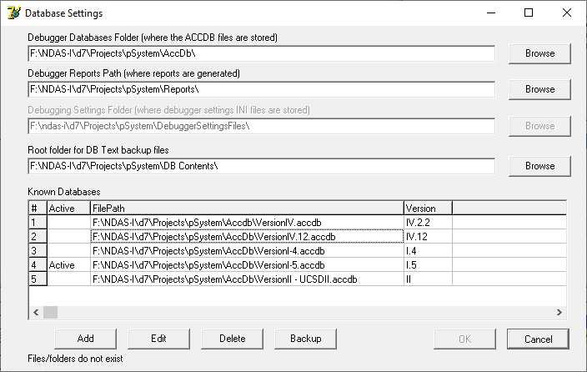

**File Name:** DBDatabaseInfoGeneral.pas

**Form Name:** TfrmDatabaseInfoGeneral

**Use:** This is activated by the Add or Edit buttons on the *TfrmDebuggerDatabasesList*

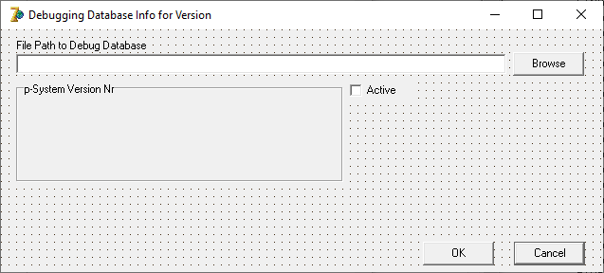

File Name: DBDatabaseInfo.pas: *TfrmDatabaseInfo*

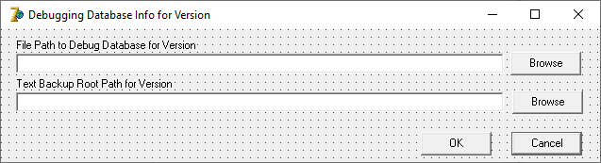

**File Name: DebuggerSettingsForm.pas**:

**Form Name:** *TfrmDebuggerSettings*

**Use:** called from *TfrmPCodeDebugger* when the *DebuggerSettings* item is selected from the file menu

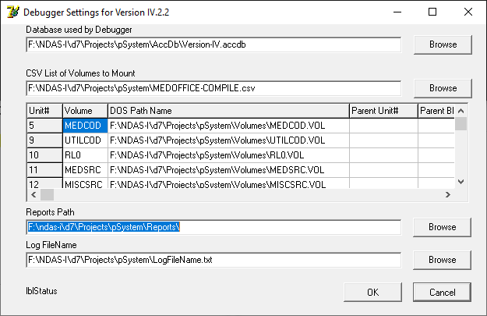

**Filename: LoadVersion.pas *TfrmLoadVersion***

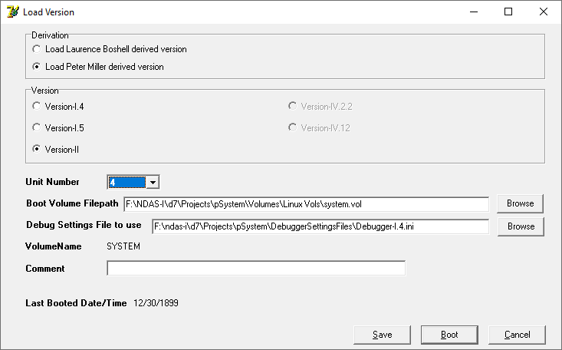

**File Name: DebuggerDatabasesList.pas- *TfrmDebuggerDatabasesList***

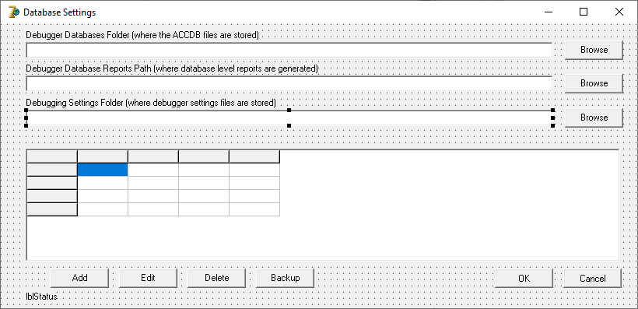

**DebuggerDatabaseUtilities**

**File Name: DbDbParameters: Scan for Version Number**

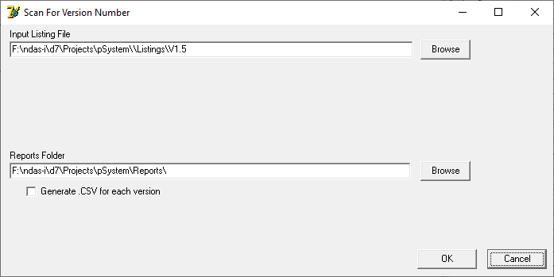

**File Name: DbDbParameters: Update Data Base from Listing**

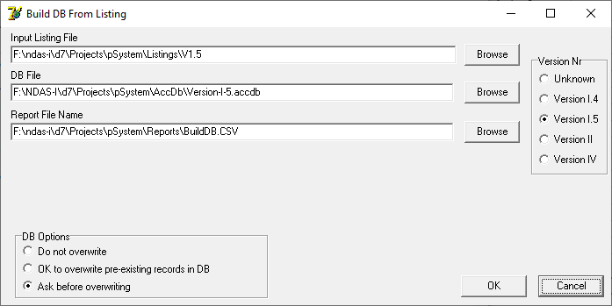

**File Name: DbDbParameters: Parse and List**

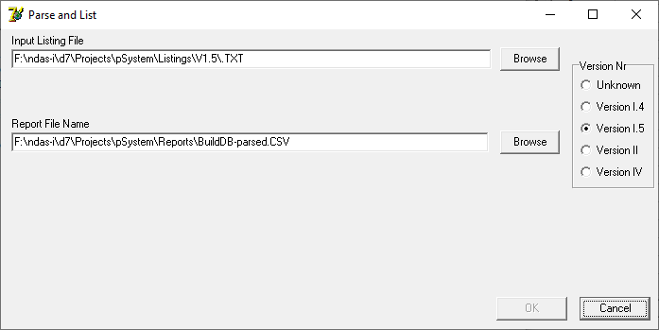

**File Name: DbDbParameters: Build Ugly Source Code from Compiler Listing**

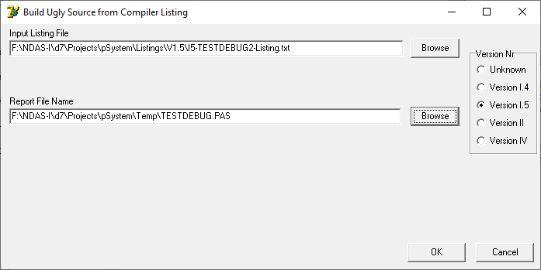

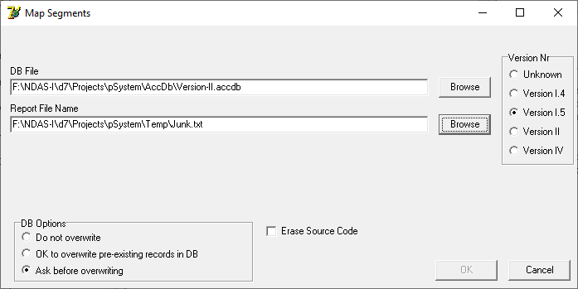

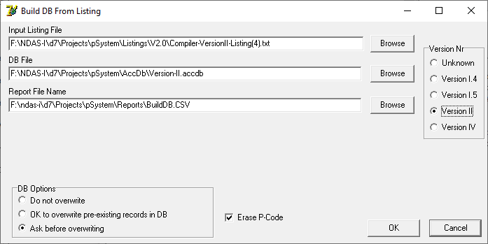

**File Name: DbDbParameters: Scan Code File and Update DB**

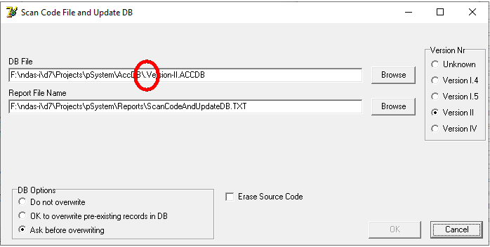

**File: DebuggerDatabasesList: Database Settings**

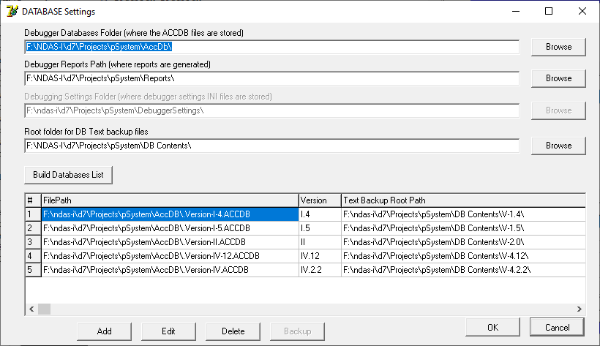

**File: DBDatabaseInfoGeneral: Debugging Database Info for Version xxx**

